
Boat rental

SLOVANKA
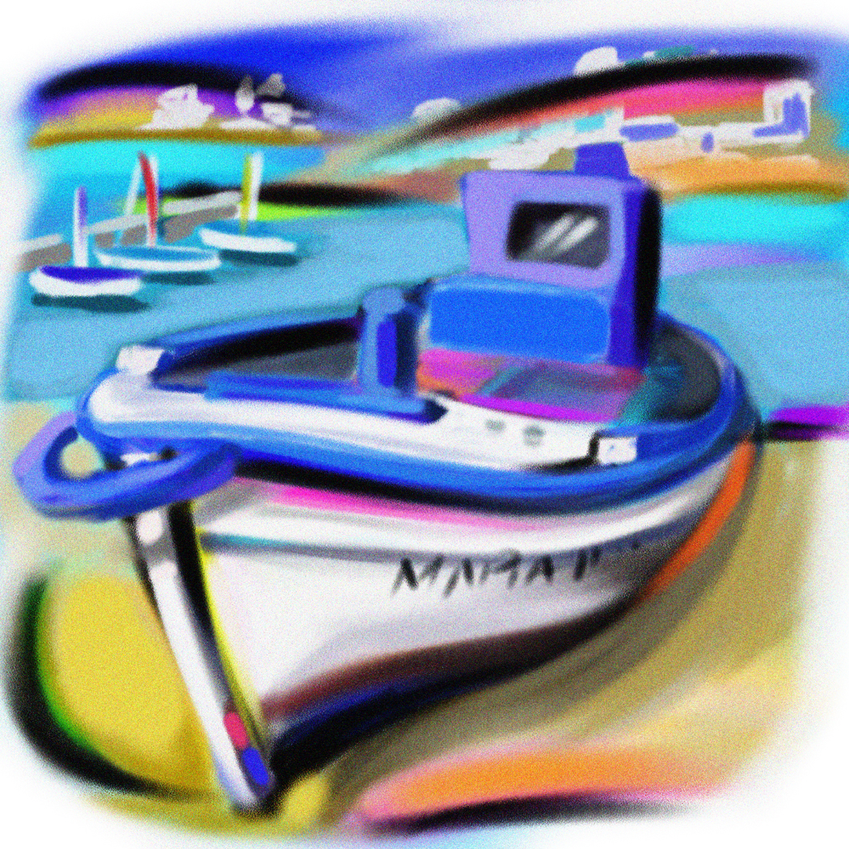

P R I C E L I S T

Pedal boat 1 hour 350,- CZK

Rowing boat 1 hour 300,- CZK

Night cruise (20:00 – 23:00) 1 hour 350,- CZK

Pedal boat for 5 people 1 hour 450,- CZK

Valid from 1.3.2025 Boat rental SLOVANKA
DIČ CZ7307300044
IČO 63659549
Accountable Manager:
Dominik Mahler

